TASK | COSHH Assessment
LOCATION OF USE | Workshop |  | Assessment  No |  | 002
PRODUCT NAME | Rocol Easyline Ultimate- all colours
DESCRIPTION OF SUBSTANCE | Paint and coatings. For industrial use only.
MANUFACTURER | Rocol Site Safety Systems Ltd
MANUFACTURERS CONTACT | ROCOL House, Swillington, Leeds,  West Yorkshire, LS26 8BS, England.  Tel: +44 (0) 113 232 2700  Fax: +44 (0) 113 232 2740  Emergency Phone Number +44 (0) 113 2322600
ASSESSOR | Martin Monaghan CMIOSH |  | Date |  | 04 12 25
TITLE | Health and Safety Consultant |  | Review by |  | 04 12 27
Personnel Performing Task  (Please list below)  Technicians/ Fitters/ Workshop Operatives |  | Time Spent  (Minutes/day)  As and when required, amounting to a few minutes per day | Training Given 
 |  |  | Yes

MSDS Revision Date | Hazard Statement
18/08/2016 | H220-Extremely Flammable Gas  H222-Extremely Flammable Aerosol  H225 Highly Flammable Liquid and Vapour  H226-Flammable Liquid and Vapour  H229-Pressurised container: may burn if heated  H304, H312, H315, H319, H332, H335, H336, h361d, H372, H373, H411

Assessment to be conducted in Association with Hazard Data Sheets, a full current copy of which must be attached to this assessment.

Please denote the hazardous properties of the substances used in the task with a 

NEW INTERNATIONAL GLOBALLY HARMONISED HAZARD SYMBOLS
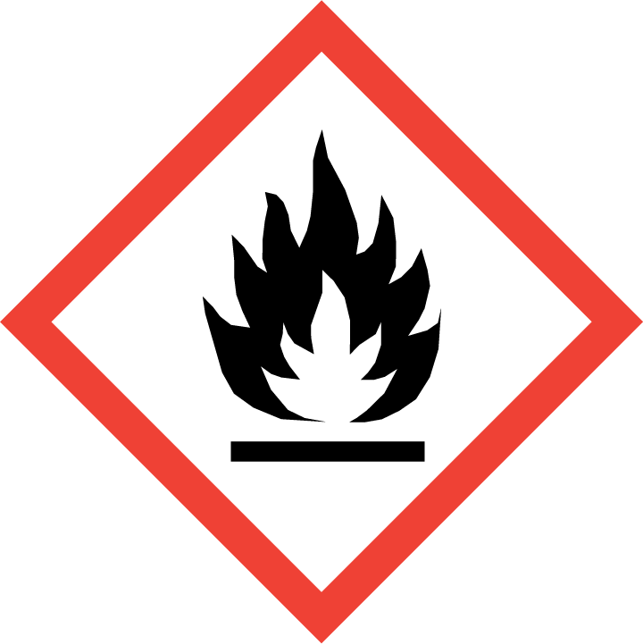 | 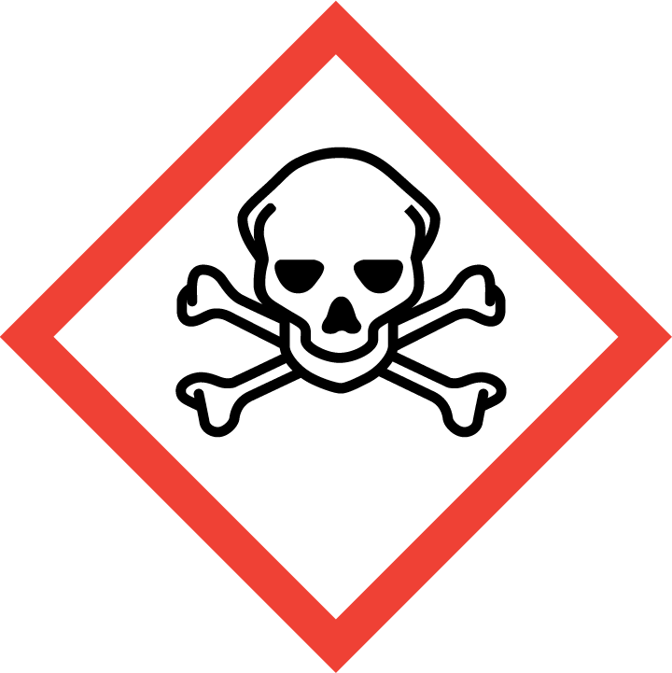 | 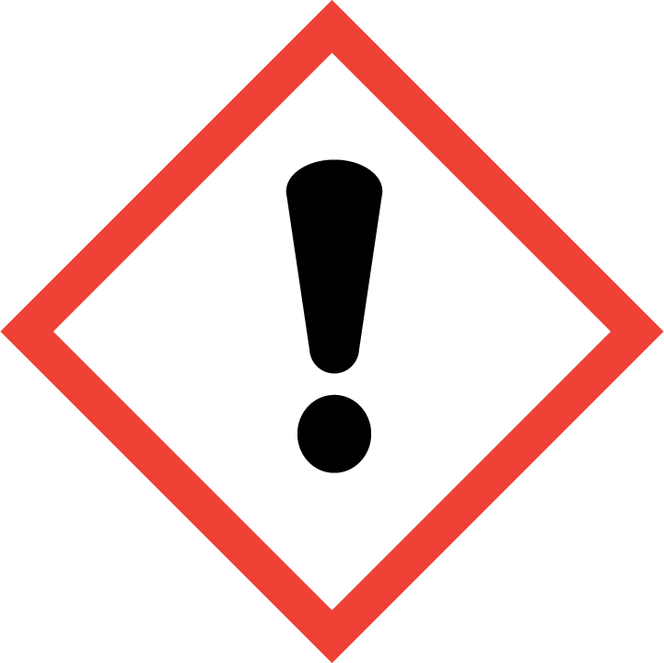 | 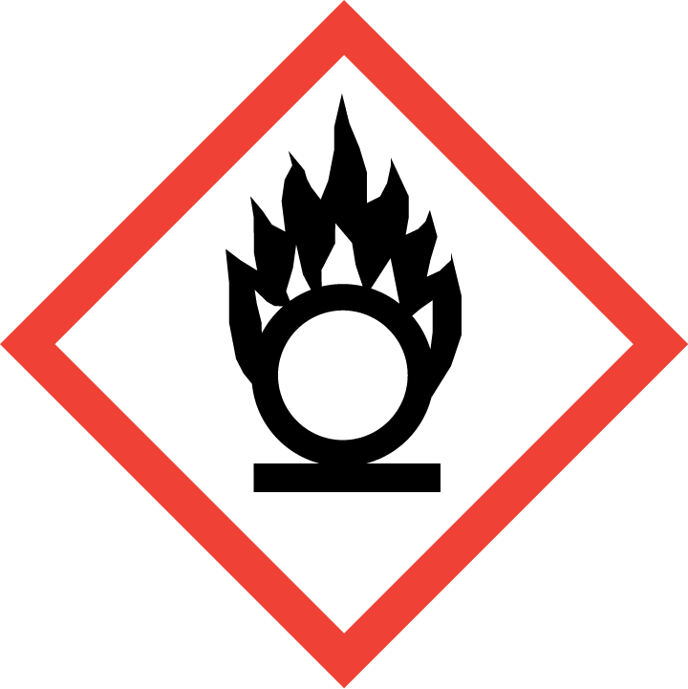 | 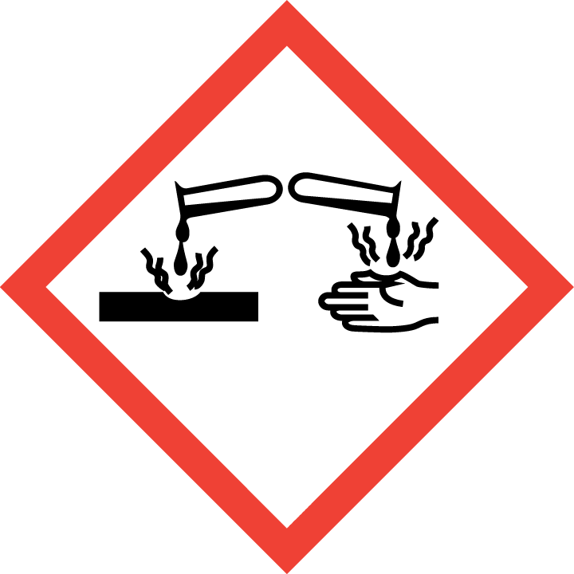 | 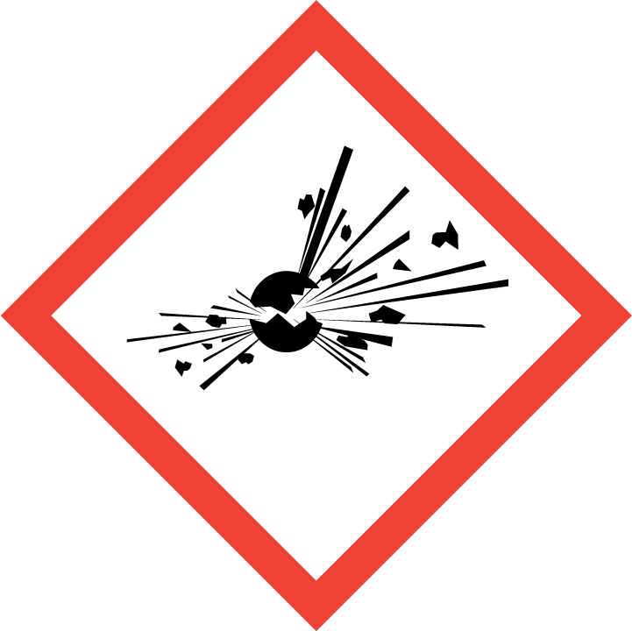 | 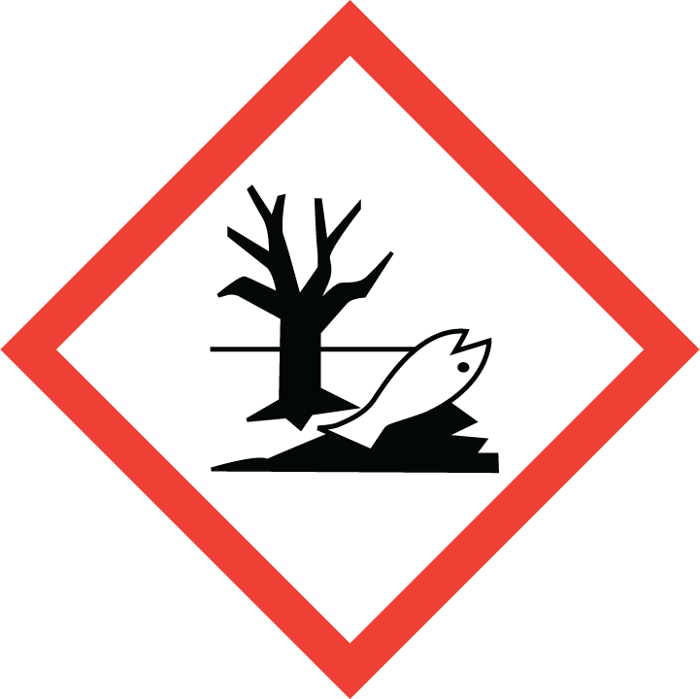 | 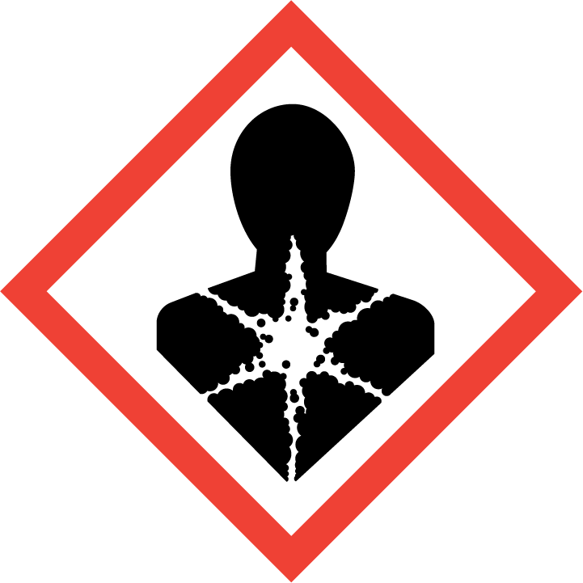
Flammable | Toxic | Harmful | Oxidising | Corrosive | Explosive | Harmful to the environment | Health Hazards i.e. respiratory sensitisation or carcinogenicity


SMOKING, EATING AND DRINKING ARE PROHIBITED IN THE WORK AREAS.
Information, Instruction and Training must be provided to all users. Young Persons, New or Expectant Mothers and other vulnerable groups must not use or be exposed to this product.

WORKPLACE EXPOSURE LIMITS (WEL’s)
DIMETHYL ETHER
Workplace exposure limits:

8 hour TWA- 766 mg/m3 15 min. STEL- 958 mg/m3

XYLENE

8 hour TWA -220 mg/m3 15 min. STEL -441 mg/m3

ACETONE
8 hour TWA -1210 mg/m3 15 min. STEL-3620 mg/m3

1-METHOXY-2-PROPANOL
8 hour TWA -375 mg/m3 15 min. STEL-560 mg/m3

ETHYLBENZENE
8 hour TWA -441 mg/m3 15 min. STEL-552 mg/m3

TOLUENE UK
8 hour TWA -191 mg/m3 15 min. STEL-384 mg/m3

STYRENE UK
8 hour TWA-430 mg/m3 15 min. STEL-1080 mg/m3

IMPORTANT!
Refer to Workplace Exposure Levels information provided in the Manufacturers Safety Data and revise control measures if exposure levels likely to be reached.

ROUTE OF EXPOSURE
Skin |  | Eyes |  | Inhalation | 
Ingestion |  | Cuts/abrasions |  | Systemic | 

PERSONS AT RISK
User of product |  | Co workers |  | Members of the public

ROUTE OF EXPOSURE |   FIRST AID MEASURES
Eyes | Bathe the eye with running water for 15 minutes
Skin | Wash immediately with plenty of soap and water.
Inhalation | Remove casualty from exposure ensuring one's own safety whilst doing so. Seek medical attention if you feel unwell.
Ingestion | Wash out mouth with water.
In all cases of doubt, or if symptoms persist seek medical attention. Never give anything by mouth to an unconscious person. If unconscious, place in recovery position and seek medical advice.

PERSONAL PROTECTIVE EQUIPMENT
 |  |  | 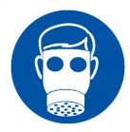 |  | 
YES | YES | YES/NO | YES/NO | YES | YES/NO
Safety glasses or goggles to EN166 | Suitable long sleeved coveralls. |  |  | PVC or rubber nitrile gloves. EN374

HANDLING | STORAGE | TRANSPORT | DISPOSAL
Avoid direct contact with the substance. Ensure there is sufficient ventilation of the area. Do not handle in a confined space. | Store in a cool, well ventilated area. Keep container tightly closed. The floor of the storage room must be impermeable to prevent the escape of liquids. Suitable packaging: Must only be kept in original packaging. |  | Do not incinerate closed containers. Plastic caps and empty aerosols may be recycled  via appropriate routes. Empty aerosols may be disposed of by authorised landfill.

REQUIRED CONTROL MEASURES
- Read Risk Assessment 006 Storage, handling and Use of Flammable Liquids and Volatile Substances before using this product.
- Users to avoid contact with skin and eyes, and inhalation of vapours/ spray or mist arising from the application of this preparation – Use PPE.
- Normal work wear.
- Ensure operatives are made aware of and understand the purpose of this assessment and SDS, plus any health implications of using the product.
- Ensure COSHH assessments with accompanying SDS are made available for all employees and users and for inspection and emergency purpose.

FIRE PRECAUTIONS
Suitable extinguishing media for the surrounding fire should be used.
Use water spray to cool containers.

ACCIDENTAL RELEASE/SPILLAGE PROCEDURES
Turn leaking containers leak side up to prevent the escape of liquid. Mark out the contaminated area with signs and prevent access to unauthorised personnel.

Environmental precautions Environmental precautions:
Do not discharge into drains or rivers. Contain the spillage using bunding.

Methods and material for containment and cleaning up Clean-up procedures:
Absorb into dry earth or sand. Transfer to a closable, labelled salvage container for disposal by an appropriate method.

MONITORING REQUIREMENTS AND HEALTH SURVEILLANCE
Health surveillance is not in place for workers exposed to this product.

